AYUSH KUMAR YADAV

21CE1256

D3

#CODE:

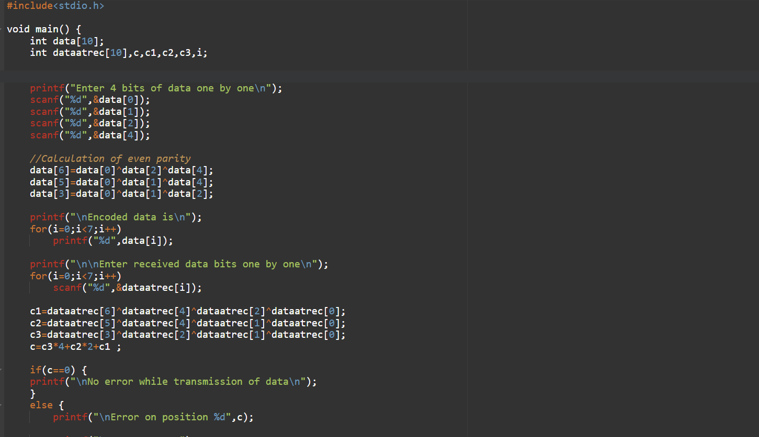

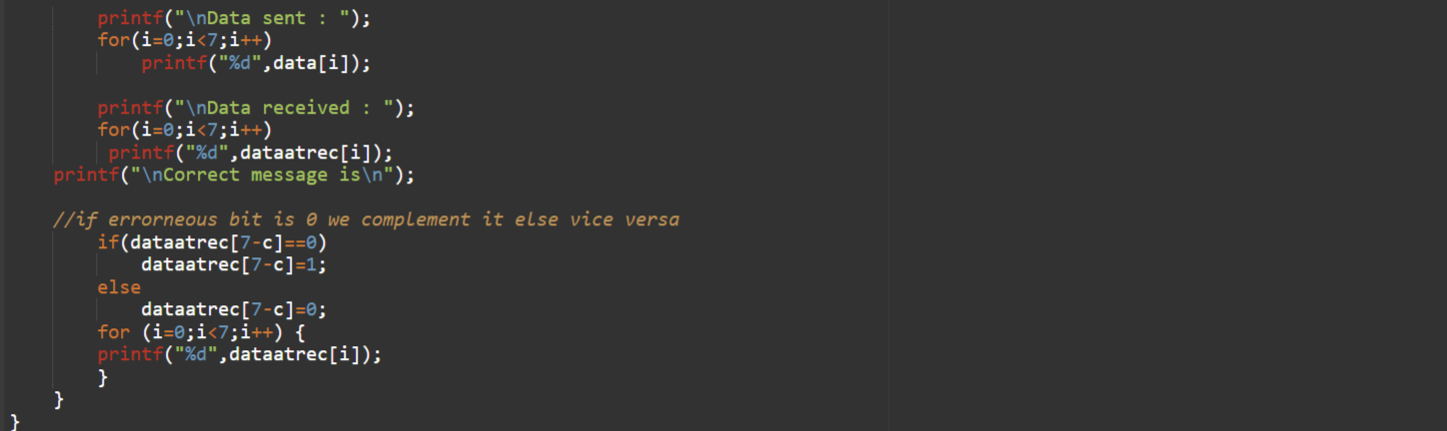

#OUTPUT:

